MRI SAFETY SCREENING QUESTIONNAIRE

Newport Diagnostic Center

Name: | Date of Birth: |  | MRN:
Today’s Date: | Height: | Weight:
Magnetic resonance imaging (MRI) systems use strong magnetic fields and radio-frequency energy for imaging soft tissue in the body. Certain implants, devices, or objects may pose a hazard to individuals in close proximity to the magnet of the MRI system and/or may interfere with the MRI procedure.

What body part is being examined today? _________________________________________________
What medical imaging tests and/or treatments have you had for this problem? (Prior MRI, injections, etc.)

______________________________ When____________________ Where _______________________
Have you had surgery in the body part that is being scanned today? ☐ Yes ☐ No
If yes, when (approximate date)? ____________ Procedure: _______________________________
Please describe your symptoms: _________________________________________________________
____________________________________________________________________________________
Do you have a personal history of Cancer? ☐ Yes ☐ No
If yes, please indicate the type of cancer: _______________________________________________
Please shade in the areas below in the figures where you are experiencing your pain/symptoms.
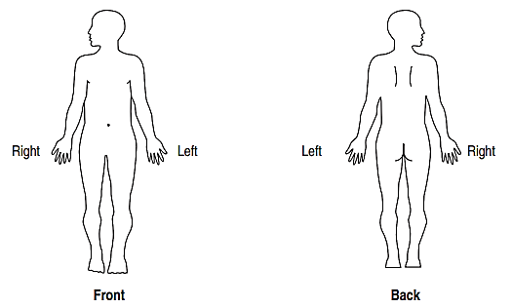
Front Back

Please continue on page 2
MRI SAFETY SCREENING QUESTIONNAIRE, continued **** Please provide any Implant Card you have.
Do you have you any of the following implants?
YES | NO
☐ | ☐ | Cardiac pacemaker or implanted cardioverter defibrillator/ICD (in place or removed)
☐ | ☐ | Aneurysm Clips or Coils
☐ | ☐ | Cardiac monitor / Loop recorder
☐ | ☐ | Internal electrodes or wires (pacing wires, DBS or VNS wires)
☐ | ☐ | Shunt (do you know the name and make of your shunt? _______________________________
☐ | ☐ | Neurostimulator
☐ | ☐ | Bone Growth Stimulator
☐ | ☐ | Implanted drug pump (ex; for chemotherapy/other pain medicine)
☐ | ☐ | Stents If yes, Where in your body? ___________________________________
☐ | ☐ | Heart Valve
☐ | ☐ | Filters / Electronic devices
☐ | ☐ | Pumps, coil, filter
☐ | ☐ | Ear (Cochlear) implant, middle ear implant
☐ | ☐ | Tissue expander
☐ | ☐ | Magnetic eyelashes
☐ | ☐ | External drug pump / or monitor (for Insulin or other medicine)
☐ | ☐ | Hearing aids (Must be removed prior to entering the MRI suite)
☐ | ☐ | IUD If yes, what Brand / type: _____________________________
☐ | ☐ | Body Piercing (you may be asked to remove all jewelry)
☐ | ☐ | Have you EVER had metal in your eyes? If yes, was it removed? ________________________

Implanted post-surgical hardware (pins, rods, screws, plates, wires)? ☐ Yes ☐ No

If yes, what and where in your body? ________________________________ ________________________

Any other implanted devices in your body not listed above? ☐ Yes ☐ No ____________________________________________________________________________________________
Are you pregnant or could you possibly be pregnant? ☐ Yes ☐ No Are you breast-feeding? ☐ Yes ☐ No

If you are still menstruating, please provide the date of your last period ____________________

Do you have a history of?
YES NO YES NO

☐ | ☐ | Kidney disease | ☐ | ☐ | Are you on Dialysis
☐ | ☐ | Diabetes | ☐ | ☐ | Allergic reaction to MRI contrast
☐ | ☐ | Drug Allergy, type: __________________________

I attest the above information is correct to the best of my knowledge. I have read and understand the entire contents of this form and I have had the opportunity to ask questions regarding the information on this form.
__________________________________________ _______ ___
Patient/Parent/Guardian/other Signature Date

